C / A / R / E

# How we can assist you to get ahead *fast*

The Story Behind CARE

“With some 2.6 billion people around the world in some kind of lockdown, we are conducting arguably the largest psychological experiment ever; This will result in a secondary epidemic of burnouts and stress-related absenteeism in the latter half of 2020’’

World Economic Forum 9th April 2020

We have developed our CARE model in response to the covid-19 outbreak in recognition that many organisations are in crisis as they figure out their strategies to keep their businesses alive and their staff employed. Beyond the negative impact of a traditional economic downturn, COVID-19 presents additional challenges—fear from the virus itself, collective grief, prolonged physical distancing and associated social isolation—that will compound the impact on our collective psyche. Daily reports of increasing infections and deaths across the world raise our anxiety, and, in cases of personal loss, plug us into grief. In change terms we are dealing with loss on a massive scale – loss of freedom, loss of the lives we love, loss of working patterns and routines, loss of space, loss of communication with family, friends and colleagues, and, most importantly for some, the loss of people they love through bereavement.

Leaders need help to act quickly not only to ensure future profitability and survival but also to recognise the human impact as staff are furloughed, laid off or working from home often in new and challenging situations. Reasons for stress abound in lockdown: there is risk of infection, fear of becoming sick or of losing loved ones, as well as the prospect of financial hardship. As a result, people are very likely to develop a wide range of symptoms of psychological stress and disorder, including low mood, insomnia, stress, anxiety, anger, irritability, emotional exhaustion, depression and post-traumatic stress symptoms. And, in cases where parents were quarantined with children, the mental health toll could be even steeper. Avoidance behaviours are also predicted, and, we can already see a sharp increase in absenteeism in countries in lockdown. People are afraid to catch COVID-19, and as a result, avoid work. And, in three to six months, just when we need all able bodies to repair the economy, we can expect a sharp spike in absenteeism and burnout. Research from Eurofound reports a loss of productivity of up to 35% for some workers.

One thing we do know is that there is no going ‘back to normal’. All of this should surprise no one. As OD consultants we have been using the ‘Change Curve’ to mitigate performance loss during change programmes for many years. And, while the insights may not be new the sheer scale of this transformation is.

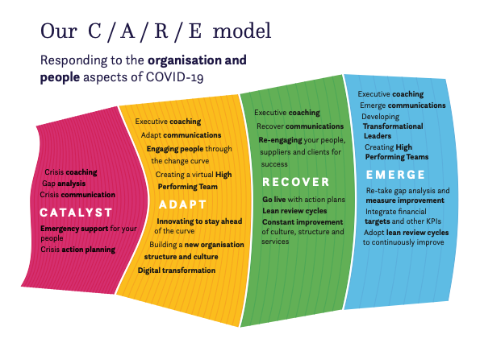

Currently, leaders are having to deal with multiple challenges and anxieties at the same time. Providing leadership and support to their people, from facing very intense new work pressures to being furloughed and having no work at all. The role of the leader is to hold the uncertainties that exist now and will persist for some time. Potentially doing so for months is a daunting ask. And to state the obvious: looking after staff also means leaders looking after themselves – being aware of their own health and wellbeing and finding ways to manage the stress while still looking to lead and help others.  Leaders can play a vital role in promoting a sense of safety, calming anxiety, supporting a sense of self and community efficacy and encouraging connectedness and hope.  The leadership behaviours of compassion, inclusivity and collaboration are needed to deliver the culture change that will help to transition organisations through the covid-19 crisis. Listening to staff and arriving at a shared understanding of the challenges they face, empathising with and supporting them, rather than always imposing decisions from the top down will also be major factors in the organisations that survive and thrive in the ‘new normal’.

We have created a roadmap that helps leaders to move ahead with confidence and has empathy and support for the well-being and mental health of everyone involved. We care about what happens to organisations and the people within them and we want this model to make a difference. Our CARE model provides a route map that mirrors where organisations are now and supports them to move forwards with confidence in uncertain times. Underneath each zone sits a playbook of a wide range of support tools many of which are available online and / or face to face to suit all situations and budgets.

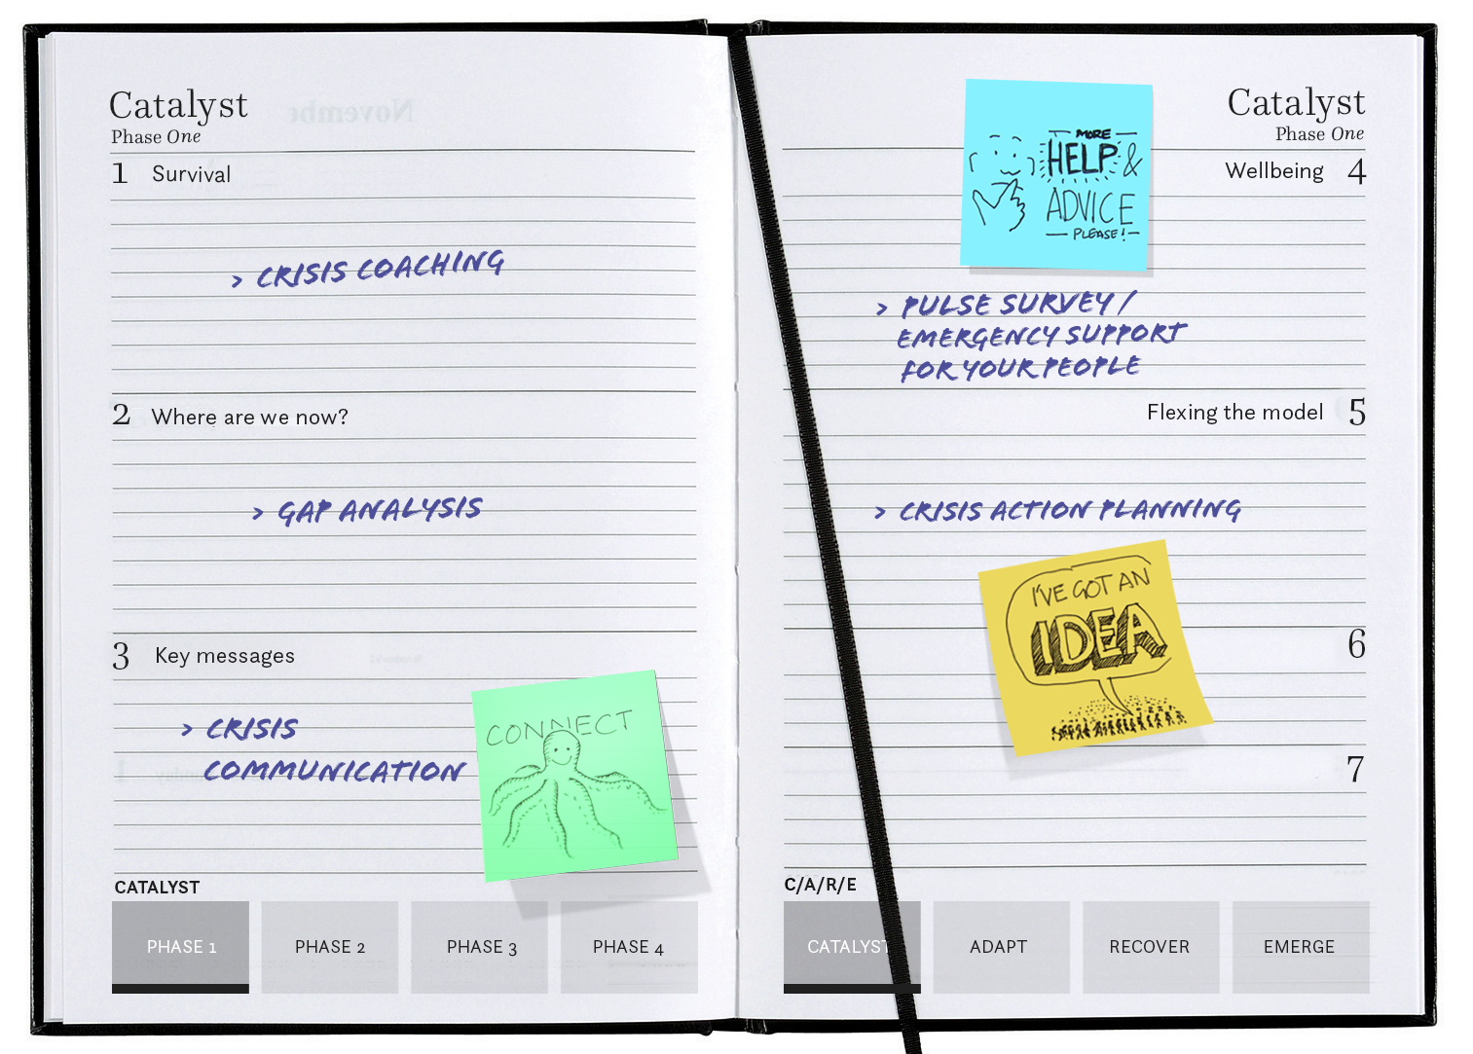

We are supporting leaders through the:

**CATALYST** zone to decide what to focus on:

* In terms of their businesses to help them to survive and deal with the additional demands generated by Covid-19
* And, communicating openly and honestly with their people providing empathy and support for their many varied situations

**ADAPT** zone to decide how to innovate to stay ahead by:

* Developing ideas for the organisation they need to become
* And, continuing to build online engaging interactions with colleagues

**RECOVER** zone to decide how to begin returning to the ‘new normal’ by:

* Creating the brand, culture and operating model and identifying the skills and behaviours that will keep them ahead
* And, building these competencies in their people to help engage them back into the workplace embedding smarter working methods

**EMERGE** zone to decide how to:

* Go-live and measure success using leaner review cycles
* Ensuring that they are creating leaders capable of the transformations necessary and of building high performing teams

# The detail

|  |  |  |  |  |
| --- | --- | --- | --- | --- |
| **Phase** | **Typical products and services** | **Delivery approach** | **Outcome / deliverable** | **Price points** |
| **CATALYST ZONE** |  |  |  |  |
| People | Executive coaching for leaders | Call off contract to deliver a series of online 1-hr sessions to:  Agree how to survive the current crisis  Produce scenarios to take to the leadership team  Maintain personal resilience | Practical strategies to assist leaders navigate this unprecedented and rapidly evolving situation.  Create scenarios for the crisis action plan  Maintain personal wellness and mental health | Call off contract of 6 sessions £2400 |
|  | Crisis Communications | Design of key messages for organisations to share with staff to stay positive, give leadership, build resilience, show empathy, stay calm, be hopeful, give practical help, FAQ sessions etc | Communications crisis plan to ensure staff get the information they need when they need it.  Staff feel informed and stay as calm as possible. | £1200 for the plan  £250 per communication |
|  | Pulse Survey to all your people | A short online survey that is sent to all staff to check how they are feeling and to engage them in defining what support they need. This can be repeated through out the CARE cycle to check progress | Leadership get feedback on what is going on (especially with staff who are largely invisible). Results feed into the communications planning cycle. | £1500 for the survey design and implementation  £1500 for set of recommendations |
|  | Setting up well-being and mental health sessions | Call off contract to deliver a series of online 1-hr coaching / mentoring / counselling sessions | Staff get crisis support to help them with their work, working from home, work-life balance, well-being, mental health | Call off contract of 10 sessions £2950 |
| Organisation | Gap Analysis | Online diagnostic for the leadership team to complete. This will explore where the organisation is right now from a people, financial, well-being, process, digital & customer perspective. | Clear focus on what needs to be done to get through the initial crisis. | £1000 for the off the shelf diagnostic  £1500 customised diagnostic |
|  | Crisis action planning and delivery | Online workshop to work with the leadership team on the results of the diagnostic (and pulse survey) to discuss immediate steps to safeguard existing day to day business and well-being of staff.  Agree immediate steps to flex existing business model to accommodate current uncertainty. | Crisis action plan with activities, accountabilities and timeline. Realistic view of starting point and immediate next steps to help business to survive. | £2400 - 3600 (includes design, delivery, write up)  *£1200 per day |
|  | Implementing faster decision making & planning models | Decision-making abilities should be calibrated to the speed of environmental changes. This online workshop with the leadership team to discuss how to work at pace in a more effective way. | Changes to processes and procedures to enable faster operating models | £2400 - 3600 (includes design, delivery, write up)  (Could be done as part of crisis planning??) |
|  | Innovating to stay ahead | Desk research and reporting on what latest thinking in the relevant industry to stay ahead of the competition. In the public sector this would be best practices in similar authorities/organisations  We can also offer innovative processes such as google sprint to design, prototype and test in record time | Recommendations about how to make changes and align with best practice.  Redesigned processes completed at pace. | £2400 (includes research and report with recommendations)  £9600 for design of sprint process, delivery of the 5-day process and write-up of results |
| **ADAPT ZONE** |  |  |  |  |
| People | Executive coaching | Online 1-hour sessions to:  Create a safe environment for leaders to try new behaviours and ways of leading  Agree potential future scenarios  Maintain personal resilience | Practical strategies to assist leaders to move ahead at pace  Ongoing action plan | Call off contract – 6 sessions £2400 |
|  | Adapt communications | Develop communications strategy and plan to delivery key messages over the next 1 – 3 months. | Staff get the information they need when they need it.  Staff stay engaged with the organisation. | Communications strategy & plan £2400  £250 per communication |
|  | Developing Resilient Leaders | Online or face to face development modules for the senior team to help give them the skills they need to get through the adaptations their organisation will need to make. | Modules focused on building resilience and self-care and development.  Highly inter-active 120-minute interactive online sessions  Or we can put together a tailored face to face or online solution for your needs. | 9 x online sessions (3 per module) £3000 / £6000 per person for all 3 modules i.e. 9 sessions  Customised programme would be POA |
|  | Facilitating online interactions with colleagues | Offer online strategies to keep staff connected, engaged motivated. For example:  Activity boosters to go out to all staff with quizzes, questions etc  Programme of online ‘off the shelf’ podcasts to help keep staff positive e.g. keeping a positive mindset/ staying calm / building resilience / navigating the personal change curve | Staff stay engaged with the organisation and attention given to their well-being and mental health. | Activity boosters £?  Off the shelf package of online generic 30-minute modules. Licence fee of £10 per person? |
| Organisation | Gathering feedback from customers and suppliers | Online diagnostic for customers and suppliers to complete. This will give feedback in terms of what is operating well and what could be improved.  Potential follow-up 1:1 calls and focus groups. | Clear focus on what needs to be done to improve services and relationships with customers and suppliers. | £1000 for the off the shelf diagnostic  £1500 customised diagnostic  £1500 for a set of recommendations each for customers and suppliers |
|  | Undertaking scenario planning | Online structured scenario planning workshop for leadership team (or ‘Plan Ahead’ team) to identify 3 – 5 possible futures and plot strategies which could work across these possibilities in order to hedge their strategic bets. | This will lead to greater executive alignment and greater resource efficiency. Result is an agreed broad direction of travel after the immediate crisis passes. | £2400 - 3600 (includes design, delivery, write up) |
|  | Re-defining purpose, vision, brand and structure | Online structured workshop to explore how the crisis has impacted the purpose, vision and core brand of the organisation. | (This naturally follows the scenario planning workshop).  Outline plans for redefined purpose, vision, brand and structure. | £2400 - 3600 (includes design, delivery, write up) |
|  | Committing to a customer-centric and digital transformation | (link to our digital culture change work)  Online or face to face to review and clarify digital ambition – what are the opportunities for a step change?  What will the journey look like?  What new skills, behaviours, processes do we need?  (Link to work on talent and culture) | (this naturally follows on from the work on innovating to stay ahead)  Report of findings and key recommendations  Support the implementation as trusted advisor | £2400 - 3600 (includes design, delivery, write up)  Role of trusted advisor @£1200 per day |
| **RECOVER ZONE** |  |  |  |  |
| People | Executive Coaching | Online / face to face 1-hour sessions to:  Agree how to implement new models at pace  Maintain personal resilience | Practical strategies to assist leaders to implement at pace.  Ongoing action plan | Call off contract – 6 sessions £2400 |
|  | Recover Communications | Develop communications strategy and plan to delivery key messages over the next 1 – 3 months e.g. how the recovery will work, staff will re-start work, SMART working etc | Staff get the information they need when they need it and have clarity about next steps.  Staff stay engaged with the organisation. | Recovery communications strategy & plan £2400  £250 per communication |
|  | Re-engaging and motivating your people | Online pulse survey, focus groups, 1:1s to de-brief on learning from the crisis.  Develop a plan for re-engaging staff back not the workplace. Clarity over any change in roles and responsibilities etc. | Key learning points from the crisis  Re-engagement plan | £6000 (5 days work) design and implementation of the engagement process and plan |
|  | Online bite size development sessions for your people | These online development sessions are designed to re-align knowledge, skills, behaviours to the adapted business model and culture | Modules focused on developing all staff.  Highly inter-active 90-minute interactive online sessions on a wide range of topics  Or we can put together a tailored face to face or online solution for your needs. | Licence fee per person to access learning  Customised programme would be POA |
| Organisation | Building the culture, values and behaviours | The business model can’t change unless the culture changes with it.  We have two workshops:  One that explicitly explores how the culture needs to change following the work on purpose, vison, brand and structure  The second explores what behaviours will and will not drive the success of the re-defined organisation. | Clear description of how the culture and brand values need to shift / change / transform following the re-design of the organisation.  A behaviours framework that highlights the core behaviours needed to deliver the re-defined culture. | Culture definition workshop  £2400 - 3600 (includes design, delivery, write up)  Getting feedback on the culture bottom up / top down £6000  Behaviours workshop  £2400 - 3600 (includes design, delivery, write up)  Creation of behaviours framework £6000 |
|  | Creating the target operating model | We would act as process consultants and coordinators in this area working with our partners to deliver a TOM. | New Target Operating Model | POA |
|  | Reassessing competency frameworks | Research and feedback from staff at all levels on the knowledge / skills / behaviours needed to drive the re-defined organisation (links to behaviours workshop above). This can be done on -line or face to face. | Competency framework to drive workforce planning and future success of the organisation. | £6000 |
|  | Pursuing humane restructuring | Support to the leadership team to introduce changes to the structure including any job losses to be dealt with in a humane way that respects the passion and effort of the people being let go. | Implementation plans | Day rate of £1200 per day |
| **EMERGE ZONE** |  |  |  |  |
| People | Executive coaching | Online / face to face 1-hour sessions to:  Agree how to implement new models at pace  Maintain personal resilience | Practical strategies to assist leaders to implement at pace.  Ongoing action plan | Call off contract – 6 sessions £2400 |
|  | Emerge Communications | Develop communications strategy and plan to delivery key messages over the next 1 – 3 months e.g. how EMERGE will work,  Review of how the recovery is going  Keeping on the pulse of how staff are feeling  Review and improve SMART working arrangements | Staff get the information they need when they need it and have clarity about next steps.  Staff stay engaged with the organisation. | Recovery communications strategy & plan £2400  £250 per communication |
|  | Developing transformational leaders | Online or face to face development modules for the senior team to help give them the skills they need to transform their organisations during the second wave of change. | Modules focused on Developing Self / Team / Organisation.  Highly inter-active 120-minute interactive online sessions  Or we can put together a tailored face to face or online solution for your needs. | 9 x online sessions (3 per module) £3000 / £6000 per person for all 3 modules i.e. 9 sessions  Customised programme would be POA |
|  | Creating HPTs | Offer online strategies to develop team leaders to enable them to keep teams connected and to share ideas about the ‘new normal’ and the new skills they may need. | Teams stay connected and are part of the ‘solution’ for the business.  Online 90 minute ‘off the shelf’ sessions and face to face modules are available. | Licence fee per person to access learning  Customised programme would be POA |
| Organisation |  |  |  |  |
|  | Re-take gap analysis and measure improvement | Online diagnostic for the leadership team to re-take. This will explore how far the organisation has shifted nd how successful this has been from a people, financial, well-being, process, digital & customer perspective. | Comprehensive evaluation of how well the organisation has done to re-design itself as required. | £1000 for the off the shelf diagnostic  £1500 customised diagnostic |
|  | Integrate financial targets and other KPIs | We would act as process consultants and coordinators in this area working with our partners to deliver a fully integrated set of financial targets and other KPIs. | Set of financial targets and KPIs | POA |
|  | Go live with action plans | Launch and coordinate implementation team. Take the ‘Strategic Action Plan’, plans for re-structuring, culture change etc and work with the organisation to deliver along with our partners. | Successful implementation and delivery of business benefits. | POA |
|  | Adopt lean review cycles to continually improve | Work at pace with our partners to continually review what is happening in the organisation. Test new scenarios and identify which to cull and which to add | Evidence based analysis on what works | POA |